**Step 1: Create an S3 Bucket**

1. **Sign in to the AWS Management Console**.
2. **Navigate to the S3 service**:
   * In the AWS Management Console, search for and select **S3**.
3. **Create a new bucket**:
   * Click on the **Create bucket** button.
   * **Bucket name**: Enter a unique name for your bucket (e.g., xyz-corporation-file-storage).
   * **Region**: Select the AWS region where you want the bucket to reside.
   * **Block Public Access settings**: You can choose to block all public access or configure access based on your requirements. If you want to allow public access, you can customize these settings.
   * Click on **Create bucket**.

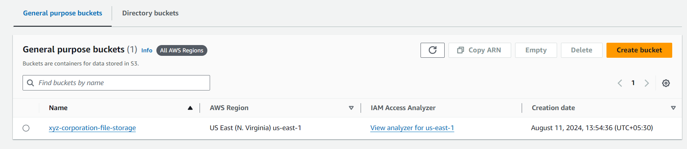

**Step 2: Upload 5 Objects with Different File Extensions**

1. **Open the bucket** you just created.
2. **Upload files**:
   * Click on the **Upload** button.
   * Click on **Add files** and select 5 different files with various extensions (e.g., .bmp, .docx, .xsl, .ppt, .txt).
   * After selecting the files, click **Upload**.

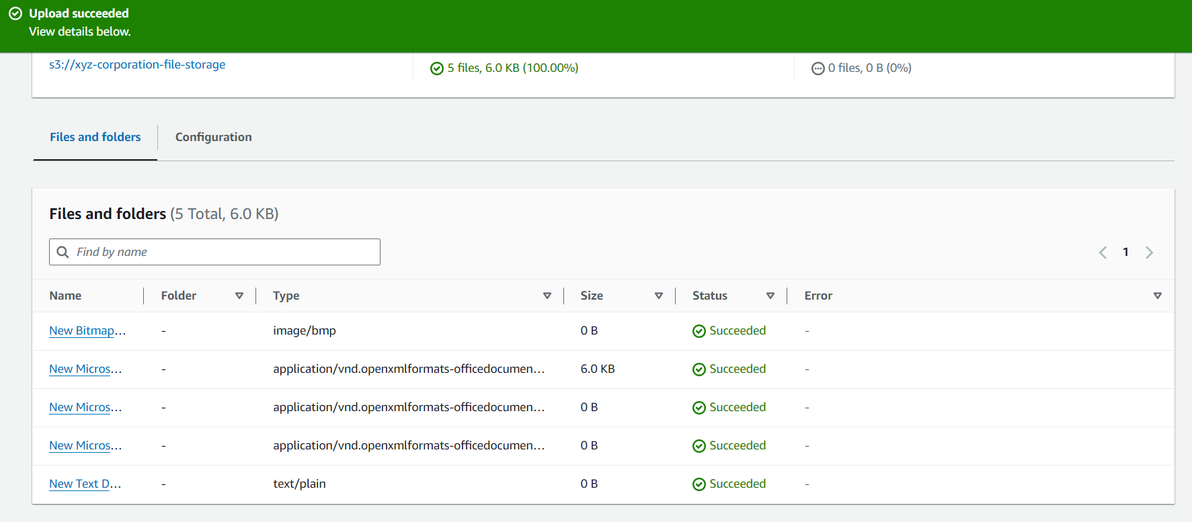

**Step 3: Confirm the Upload**

* After the upload is complete, you should see the files listed in your S3 bucket. You can click on each file to view its details and permissions.